NAME: ANKON SARKER LINKON

ID:19-40895-2

SEC:B

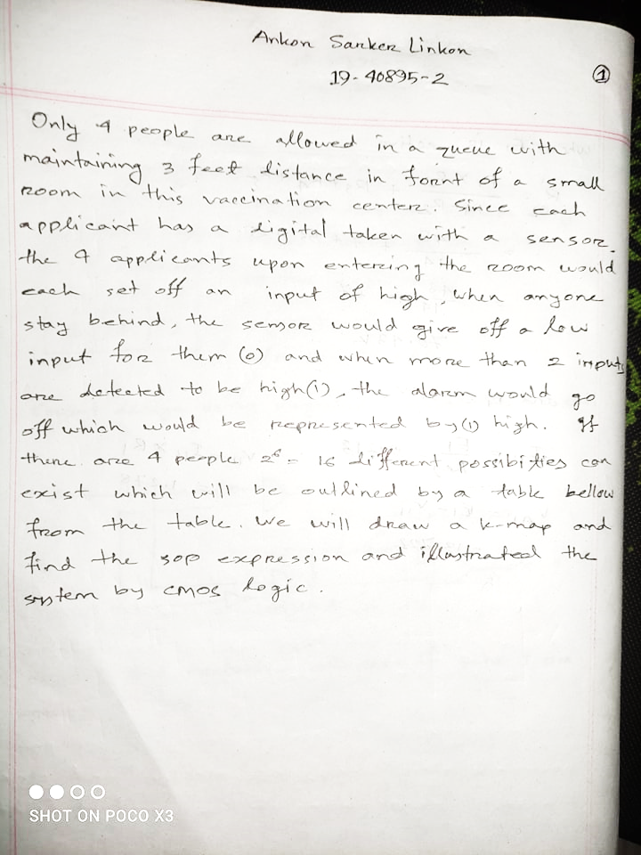

For 4 people, We consider A, B, C, D.

